AP World History – Unit 1: Foundations, 8000 B.C.E. to 600 B.C.E.
Questions: The Indus Valley Civilization Crash Course World History #2
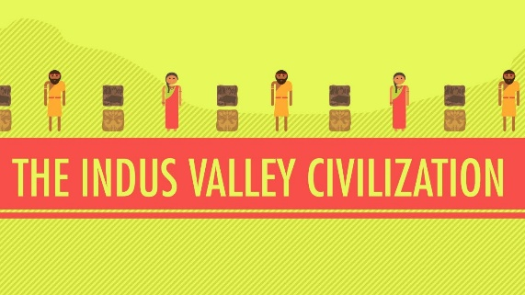
Directions: Watch the video “The Indus Valley Civilization: World History Crash Course #2” on www.youtube.com and answer the questions below on this page or another sheet of paper.

- What are the characteristics of a civilization and why can that term be problematic?
- Why were the vast majority of ancient civilizations centered around river valleys?
- Where was the Indus Valley Civilization located and why was this area such a great place to build a civilization?
- When did this civilization flourish and how do we know about the people?
- So what were some distinguishing characteristics of the Indus Valley civilization?
- When did the Indus Valley Civilization decline and what happened to these people?
- Why did these people decide to build a civilization here in the first place?
- After watching the video, determine why studying civilizations of the past can help us figure out our own human nature. In other words, why study history?

AP World History – Unit 1: Foundations, 8000 B.C.E. to 600 B.C.E.
Questions: The Indus Valley Civilization Crash Course World History #2
Directions: Watch the video “The Indus Valley Civilization: World History Crash Course #2” on www.youtube.com and answer the questions below on this page or another sheet of paper.

- What are the characteristics of a civilization and why can that term be problematic?
- Why were the vast majority of ancient civilizations centered around river valleys?
- Where was the Indus Valley Civilization located and why was this area such a great place to build a civilization?
- When did this civilization flourish and how do we know about the people?
- So what were some distinguishing characteristics of the Indus Valley civilization?
- When did the Indus Valley Civilization decline and what happened to these people?
- Why did these people decide to build a civilization here in the first place?
- After watching the video, determine why studying civilizations of the past can help us figure out our own human nature. In other words, why study history?

