Name: Period:
How Did We End Up in China?
Use each of the QR Codes to access videos and readings to answer the questions. At the end respond to the Essential Question for today:
How did the Chinese civilization begin and to what extent did religion impact its development?
- Rethinking Civilizations:
- What area was central to the build-up of early civilizations?
- What was the impact of having a food surplus?
- How does the idea of being under state control impact the attitude about being “civilized”?

- The Mandate of Heaven:
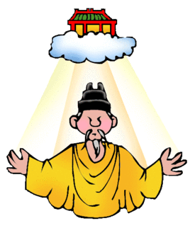 | The Mandate of Heaven is…  (Explain in 2-3 sentences)!

- The First Dynasties:
- What area did the early Chinese people settle in? What was the first dynasty called?
- What was the Warring State Period characterized by?
- Which dynasty reunified China?

- The Qin Dynasty:
- Write the name each philosophy to its correct description:
_______________________ | _______________________ | _______________________
Human beings must obey the unyielding will of the universe, literally the dao—The Way. Rather than involve themselves in the complex workings of the state, followers urged detachment, self-sufficiency, and deliberate ignorance of worldly things. | The state's operations are more important than personal liberty, and adherence to the law is the most important thing. Apply and uphold the law by any means necessary. | Obeying your elders and social superiors is the utmost civic virtue; maintaining morality, respect, and activism is what keeps a society functioning.
- Why did King Zheng need to “claim” the Mandate of Heaven?
- How did Qin Shi Huangdi apply legalism during his reign?
- What is the advantage of standardized weights and measures and common languages?
- Han Dynasty
- What did the Han dynasty maintain from the Qin?
- To have able and educated officials in the bureaucracy, what did Emperor Wu establish?
- Confucianism
- What is Confucianism?
- Why did Confucius emphasize the study of history?

Respond to your essential question below in 3-4 complete sentences.
How did the Chinese civilization begin and to what extent did religion impact its development?

